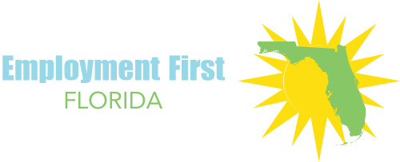
Series Title: Employment First Success Stories: Employment Services

Title: CareerSource Florida partners with organizations to address barriers that often coexist with disabilities

The Employment First Florida Success Stories series highlights examples of innovative employment services, creative state agency employment practices, and individual employment success stories in Florida. The series is a product of the EmployMe1st project, a joint project of the Florida Developmental Disabilities Council, the Institute for Community Inclusion at the University of Massachusetts Boston, and the National Association of State Directors of Developmental Disabilities Services.
Description of the practice:
CareerSource Florida is the statewide agency responsible for compliance with workforce-related legislation. It creates policies that local workforce boards implement to increase community access to work opportunities. CareerSource Florida often collaborates with other agencies to organize job fairs, conferences, and other opportunities to connect the business community with job seekers, including those with disabilities.
Over the past two years, CareerSource Florida has partnered with other agencies to develop Florida’s state-level Workforce Innovation & Opportunity Act (WIOA) plan. States’ plans are either combined—involving a greater number of partners mandated by state level statute and law—or unified, involving only the federally mandated core partners needed to participate in all state WIOA plans.
Florida has a unified plan and CareerSource Florida is a member of the Employment First Collaborative Team (EFCT), providing assistance to other agencies on the team as necessary and focusing on their special initiatives, such as co-sponsoring job fairs, the Family Café, and the EFCT’s annual report. The agency also has made sure that core WIOA partners (Florida Department of Education, Division of Career and Adult Education, Florida Division of Blind Services, and Florida Division of Vocational Rehabilitation) speak about and implement the unified plan at the local level.
However, CareerSource Florida has taken steps to move beyond the unified plan and bring in other organizations to address other barriers to employment that frequently coexist with disabilities. CareerSource Florida’s policy analyst, Warren Davis, is a member of councils that connect to the work of other partners, such as Independent Living Councils and homelessness councils. Although CareerSource Florida does not deliver direct services to people served by these organizations, it has facilitated their ability to offer local-level solutions, such as micro-enterprise grants and career center navigators, to encourage people to pursue employment.
CareerSource Florida’s board of directors has significantly driven the behavior performance of local workforce investment boards to align with WIOA’s provisions. For example, the board used Department of Labor funds, received before WIOA was passed, to create incentives for local workforce boards to work with populations that have been hard to serve. CareerSource Florida assesses the local boards on five metrics related to business and client services, and gives them additional points on their scores if they are serving individuals in hard-to-serve populations.
Lessons learned:
CareerSource Florida’s grant from the U.S. Department of Labor’s Workforce Innovation Fund to drive the behavior of local workforce boards is the first funding model of its kind in the nation. CareerSource Florida’s Warren Davis and Jacqueline Barreiros commented that the grant’s purpose is to “lift all boats”—that is, to identify pockets of innovation and better strategies to support all workforce boards. This project has also made it possible for local workforce boards to serve people directly at career centers without first referring them for employment services through vocational rehabilitation or the Association for Persons with Disabilities.
CareerSource Florida is required every two years to review the four-year unified plan to know if they have achieved milestones and to assess strategies that worked or need to be tweaked. As of summer 2018, they are waiting for the newest labor market data to continue these assessments.
For more information, contact: https://pfm.careersourceflorida.com/

